APPLICATION FORM: COMMUNITY GROUPS APPLYING FOR FUNDING TO ASSIST WITH THE ORGANISATION OF A CYCLING THEMED EVENT DURING BIKE WEEK – from 19th – 27th September

Before completing this form please make yourself and your organisation aware of the following terms and conditions:
- The types of groups which may apply are community groups, voluntary organisations, schools, sports clubs, active retirement groups, childcare service providers, workplaces or any group that wishes to organise a bike related event on a 'not for profit basis' during Bike Week 2020.
- Events must be held during Bike Week 2019: from 19th – 27th September 2020
- All events must be FREE to the public/participant.
- All events/programmes must comply with Covid_19 guidelines
- Bike Week logo must be used on all materials.
- Only events/organisations based in Longford County are eligible to apply for funding under this scheme.
- Event insurance: Longford County Council and Longford Sports Partnership shall not be liable for any claims arising from events. The grantee shall indemnify Longford County Council and Longford Sports Partnership for and in respect of all and any losses, claims, demands, damages, or expenses arising from any event related cause whatsoever. NB: A letter from your organisation's insurance company indemnifying the above and giving details regarding insurance cover of the proposed event must accompany this application. Failure to do so may mean that funding will not be made available. We advise all groups to contact their insurers prior to making any application for funding.

- Where events are taking place on the public road the Gardai and relevant Local Authority must be notified in writing of your intention to organise the event. Permission must be received.
- Adherence to Child Protection Guidelines: Where children or young people are participating as part of the event, organisers should familiarise themselves with Cycling Ireland's 'Code of Practise and Safeguarding Procedures for Young and Vulnerable Cyclists' which can be found at http://www.cyclingireland.ie/downloads/ci%20code%20of%20conduct.pdf. Events for children and young people should ensure a ratio of at least 1 adult to 6 children with a minimum of 2 adults per group.
- This application process requires submission of an outline proposal (see form below) to Longford Sports Partnership for approval.
- A dedicated contact person from your organisation should be appointed. Full details for that contact person (email address and telephone number) must be submitted as part of this application process.

- For the purposes of these grants, eligible expenditure will include:
- Costs involved in organising local fun cycling events for public participation;
- Costs involved in organising public information events on cycling;
- Cost of free bike check-ups in public areas;
- Costs of purchase of items such as lights, locks, bells etc to raffle or give as prizes for participants in events;
- Costs incurred in provision of cycling training;
- Costs of complementary activities for event days, e.g. musical entertainment, face painting, novelty bike displays
- Costs relating to publicity for events.
- Completed applications should be e-mailed to sports@longfordcoco.ie or, alternatively, application forms can be posted to BikeWeek 2020, Longford Sports Partnership, Longford County Council, Camlin Court Building, Longford, Co. Longford. The closing date for application is 12 noon, Monday 7th September 2020.
- The dedicated contact person will be informed of the outcome.
- Grants available amounts depend on applications received.
- You will need to ensure that your organisation has the capacity to absorb the costs of organising this event (paying invoices to suppliers etc.) until such time that the payment of the grant issues.
- Following Bike Week, and as a condition of payment, a brief report on the event must be submitted. The report should consist of:
- Copies of paid invoices relating to expenditure on the event itself.
- A brief account of the event (less than 500 words).
- At least two photographs of the event-preferably received by e-mail as JPG, PDF etc.
- Copies of any media coverage that the event received.
- The post event report will need to be furnished to the above e-mail/postal address on or before Friday, 9th October 2020.
- Grants will be paid to the organising group which shall be responsible for submitting a claim for payment following Bike Week and will issue as soon as possible following satisfactory receipt of the claim and the report on the event.

Examples of possible Bike Week events include (but are not limited to):
- Guided bike tour of a town/village. These can be themed, for example, heritage, gardens, or food trips.
- Cycles from your school to a local amenity on cycle to school day for bike based games such as treasure hunts and slow bicycle races;
- A midsummer night cycle
- Bike hurley or camogie
- Bike maintenance workshops
- Bike art exhibition
- Bike school art competition, quiz or drama
- Family fun cycle
- Bike fashion show
- Cycling window display competition in local shops
- Picnic cycle
- Fancy dress bike parade.

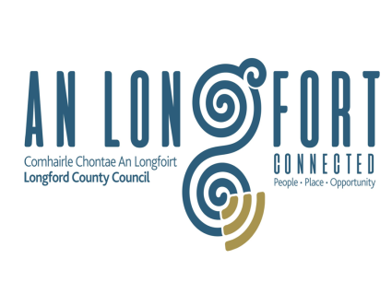
For further details, please contact Longford Sports Partnership, Longford County Council, Camlin Court Building, Great Water Street, Longford Tel: 043 33 43493 or log onto www.longfordsports.ie.
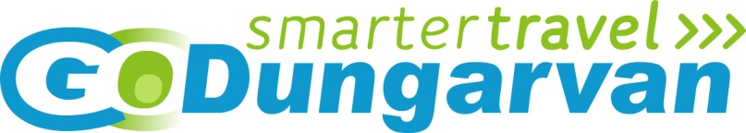
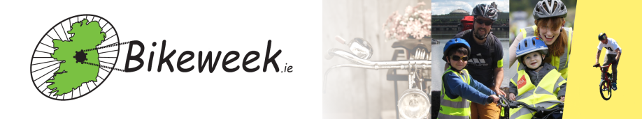

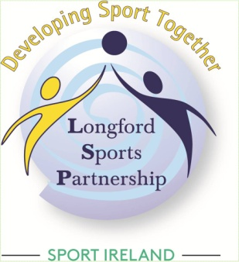

APPLICATION FORM

1) Organiser's Details
Organisation name
Organisation contact address
2) Contact details
Contact person’s name

Landline number

Mobile number where possible

Email address
Planned Bike Week 2020 event
3) Outline of planned event:
(a.) Event Title:

(b.) Brief Description:

(c.) Target Audience (e.g. young people, families, older age groups etc.):

(d.) Anticipated number participating:

(e.) Indicate proposed date(s) for your Bike Week 2020 event:
Preferred Date 1:

Preferred Date 2:
4) Organiser's Insurance Details
(a.) Company:

(b.) Type of cover applicable to this event (e.g. public liability, personal accident):

(c.) Letter from insurance company submitted with this application(as per point 6 Terms and Conditions): Yes No

If 'No' please give reason:_______________________________________________________________
5) Indicative Funding sought:

Area(s) of Expenditure | Estimated cost €
Total
Area(s) of Income | Estimated cost €
Total

6) Declaration by main contact person:
I hereby apply for approval for grant funding as part of the Longford County Council scheme to assist Community Groups with the organisation of a cycling themed event as part of Bike Week 2019 (19th to 27th September 2020). I also declare (on behalf of the above named organisation) that I have read and understood the terms and conditions on page 1 and 2 of this application:

_________________________
Signed

__________________________
(Name in Capitals and Title)

Date:______________________

